Pari’s Fiscal Barometer Notes (9/25/2014)

**Panel: Fiscal Impetus**:

* **Caption:** The html for linking to the methodology file is actually showing up in the caption.

**Panel: Jobs and Public Construction**

* **Panel-View:** In the panel-view of all three charts, the y-axis values for Monthly Change in Federal Employment are cut off on the left.

Chart 1: State+local Employment & Chart 2: Federal Employment

* **Legend**: Need a space between “3-Month” and “Moving average”
* **Tooltip:** The tooltip for December 2008 still shows up (is there any way we could have it be blank for the first value?

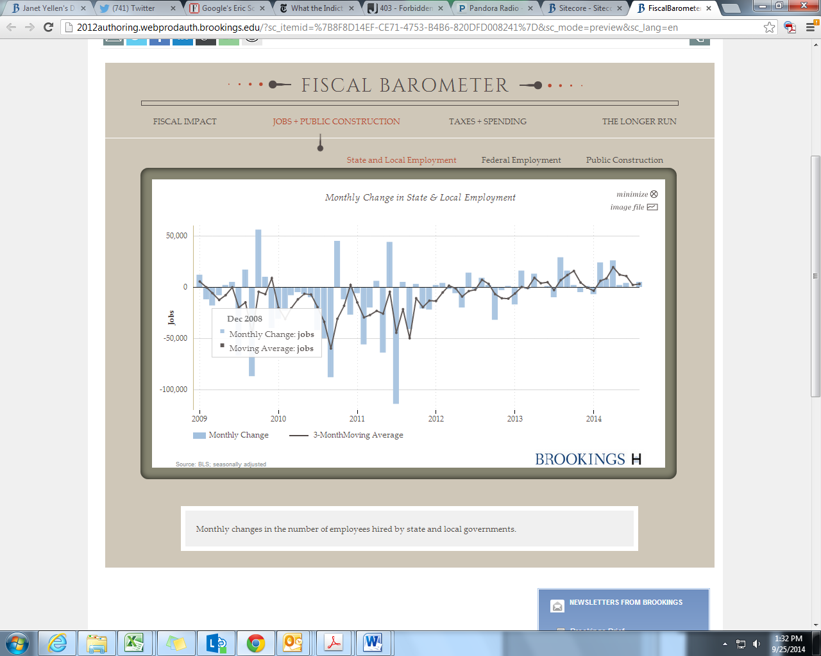 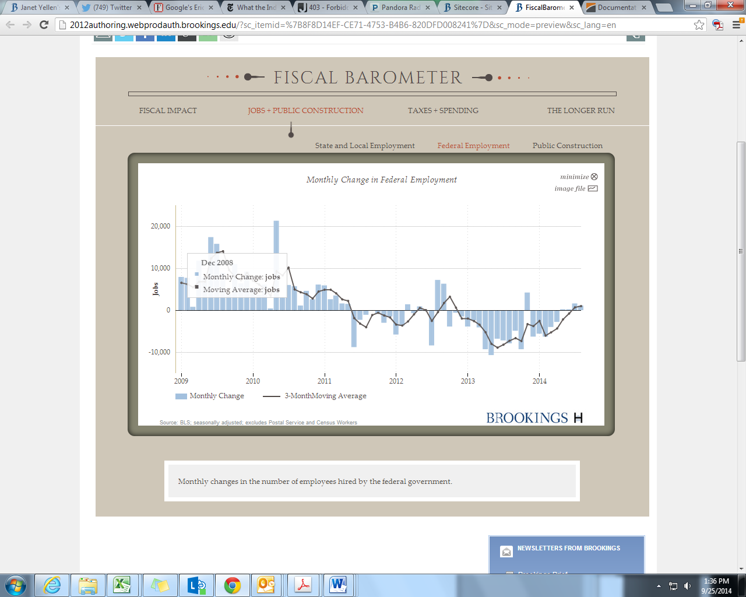

**Panel: Taxes + Spending**

Chart2: Federal Receipts and Outlays (the table)

* **Caption**:Missing
* **Table Formatting**:Can you format Total Outlays the same way as Total Receipts? (right now Receipts is bolded and justified left)
* **Source/Notes:** The notes for the table are overlapping with the Brookings/Hutchins logo. It might help to move the notes underneath the source on the left side to avoid having to re-size things.

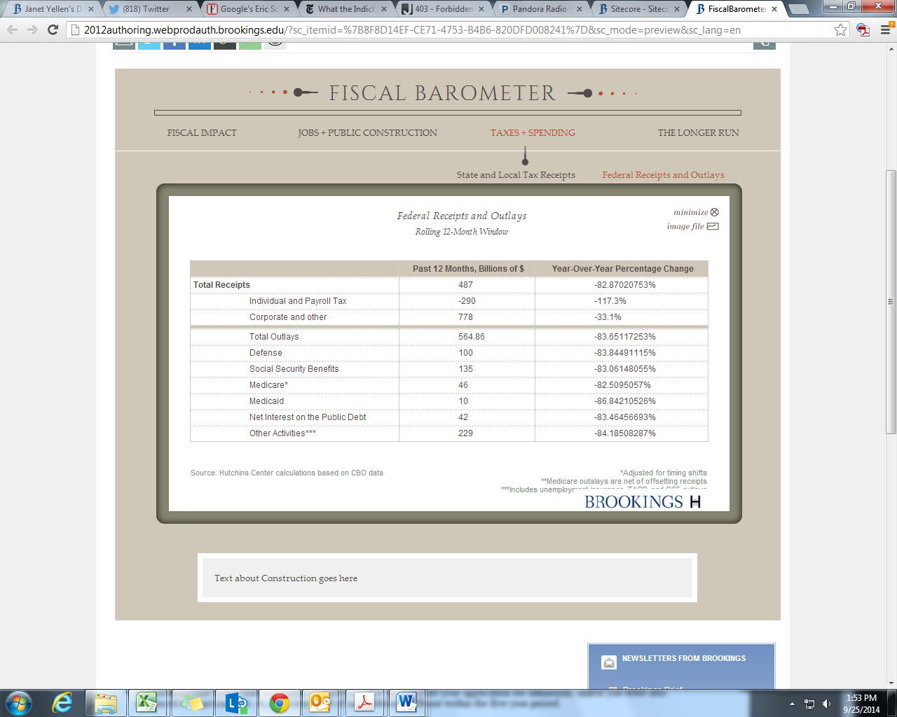

**Panel: The Longer Run**

Chart 2: Federal Budget Deficit or Surplus

* **Tooltip**: Could you have the number be comma-separated (i.e. 1,520 versus 1520)

Chart 3: Debt Held by the Public

* **Tooltip**: The units should be “%”, not “billions”